1.) PWD

Present work Directory

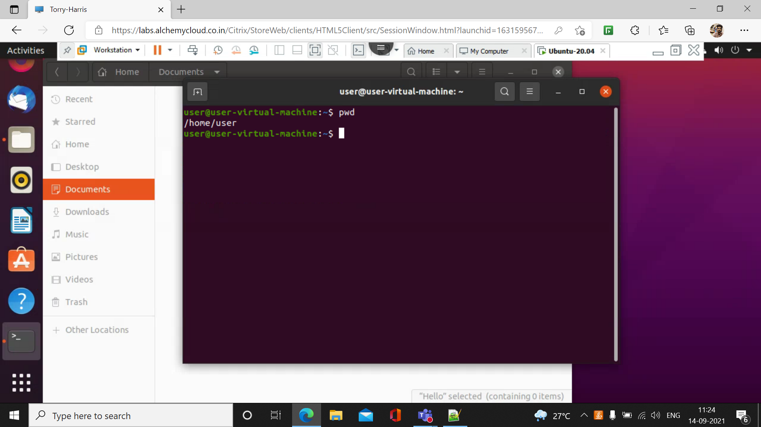

2.) ls

It is used to list all the directory

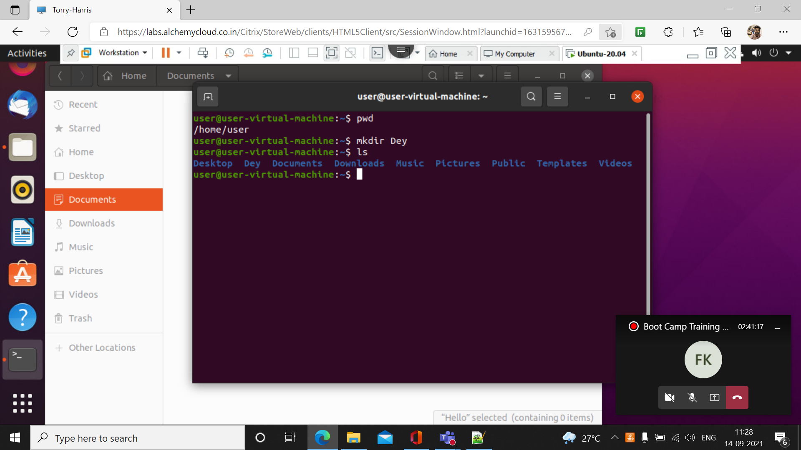

3.) mkdir

It is used to create a directory



4.) ls –l

It is used to represent all the directories in a list

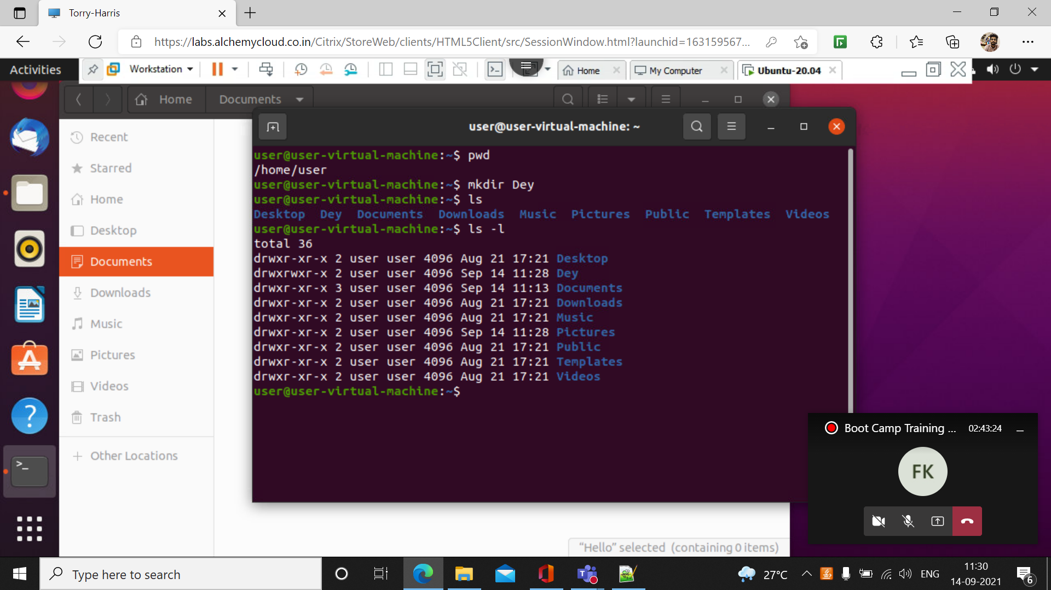

5.) rmdir

It is used to remove the directory

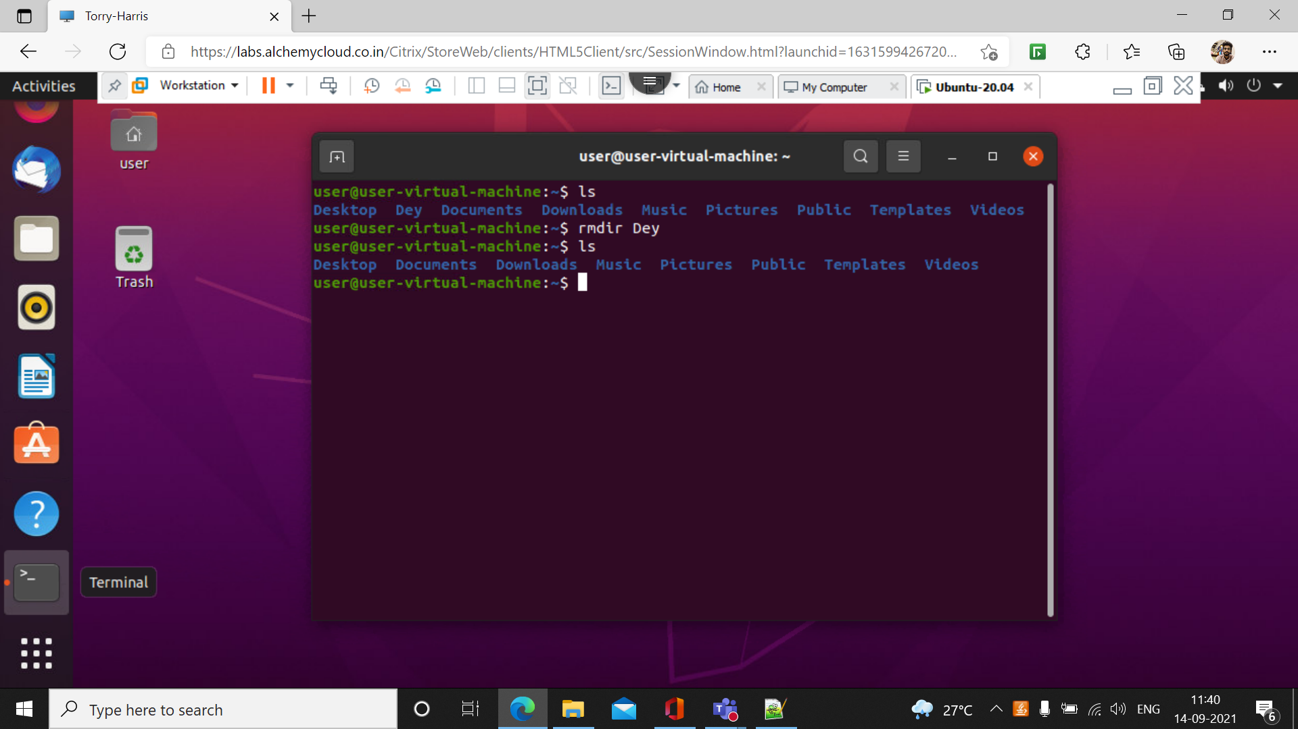

6.)rmdir

It is used to rename the Directory

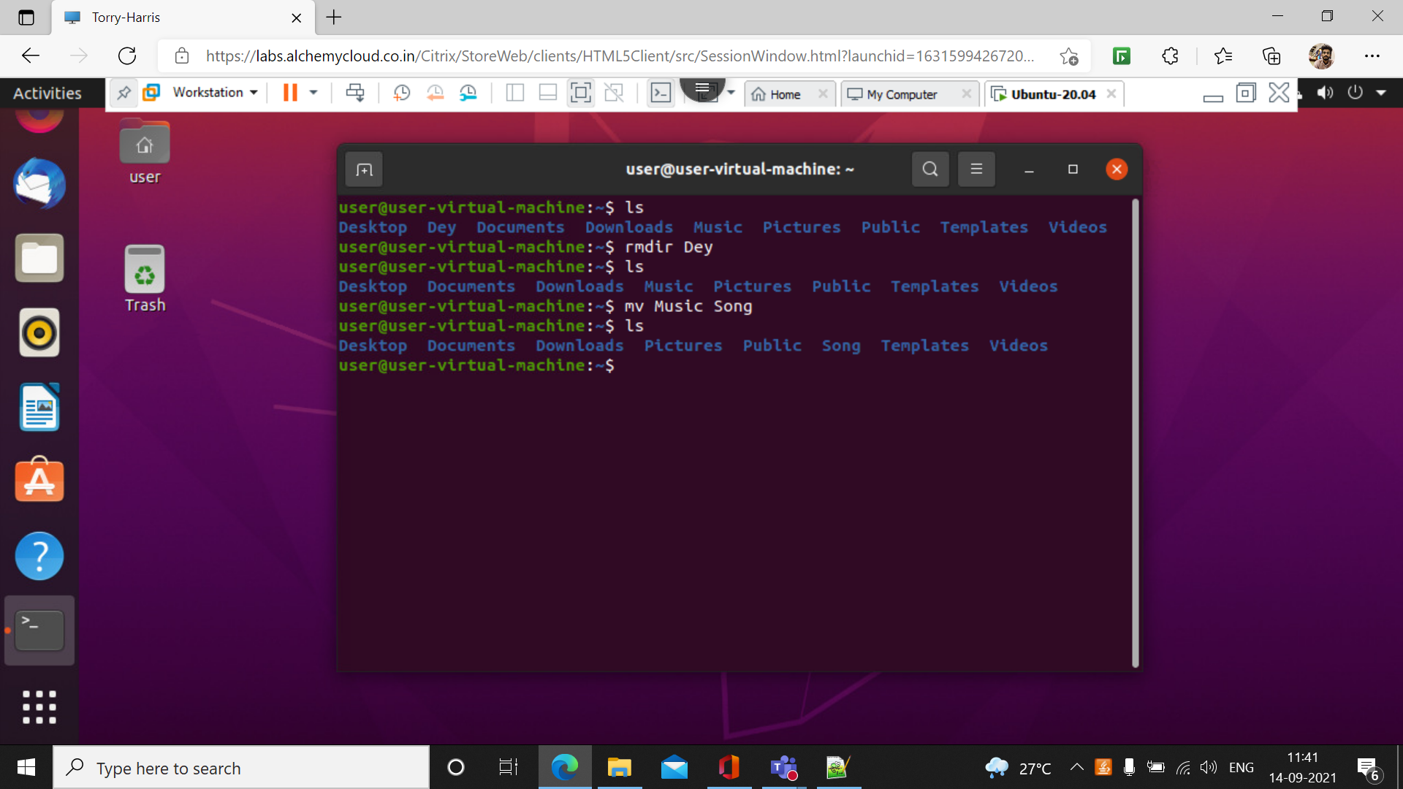

7.) cd

It is used to change the directory

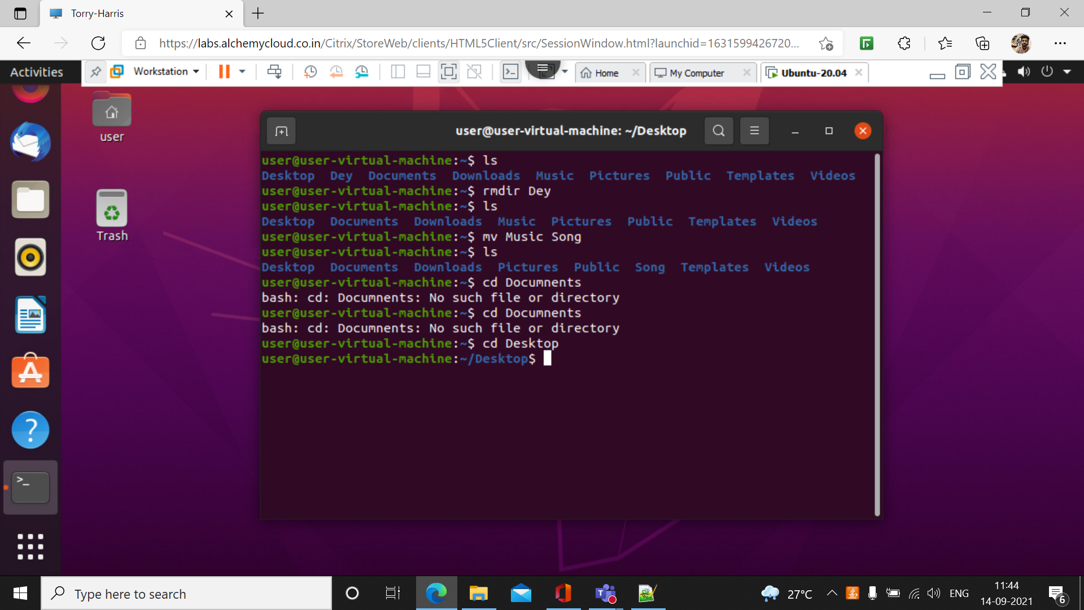

8.) cd ..

This command is used to move one step back word.

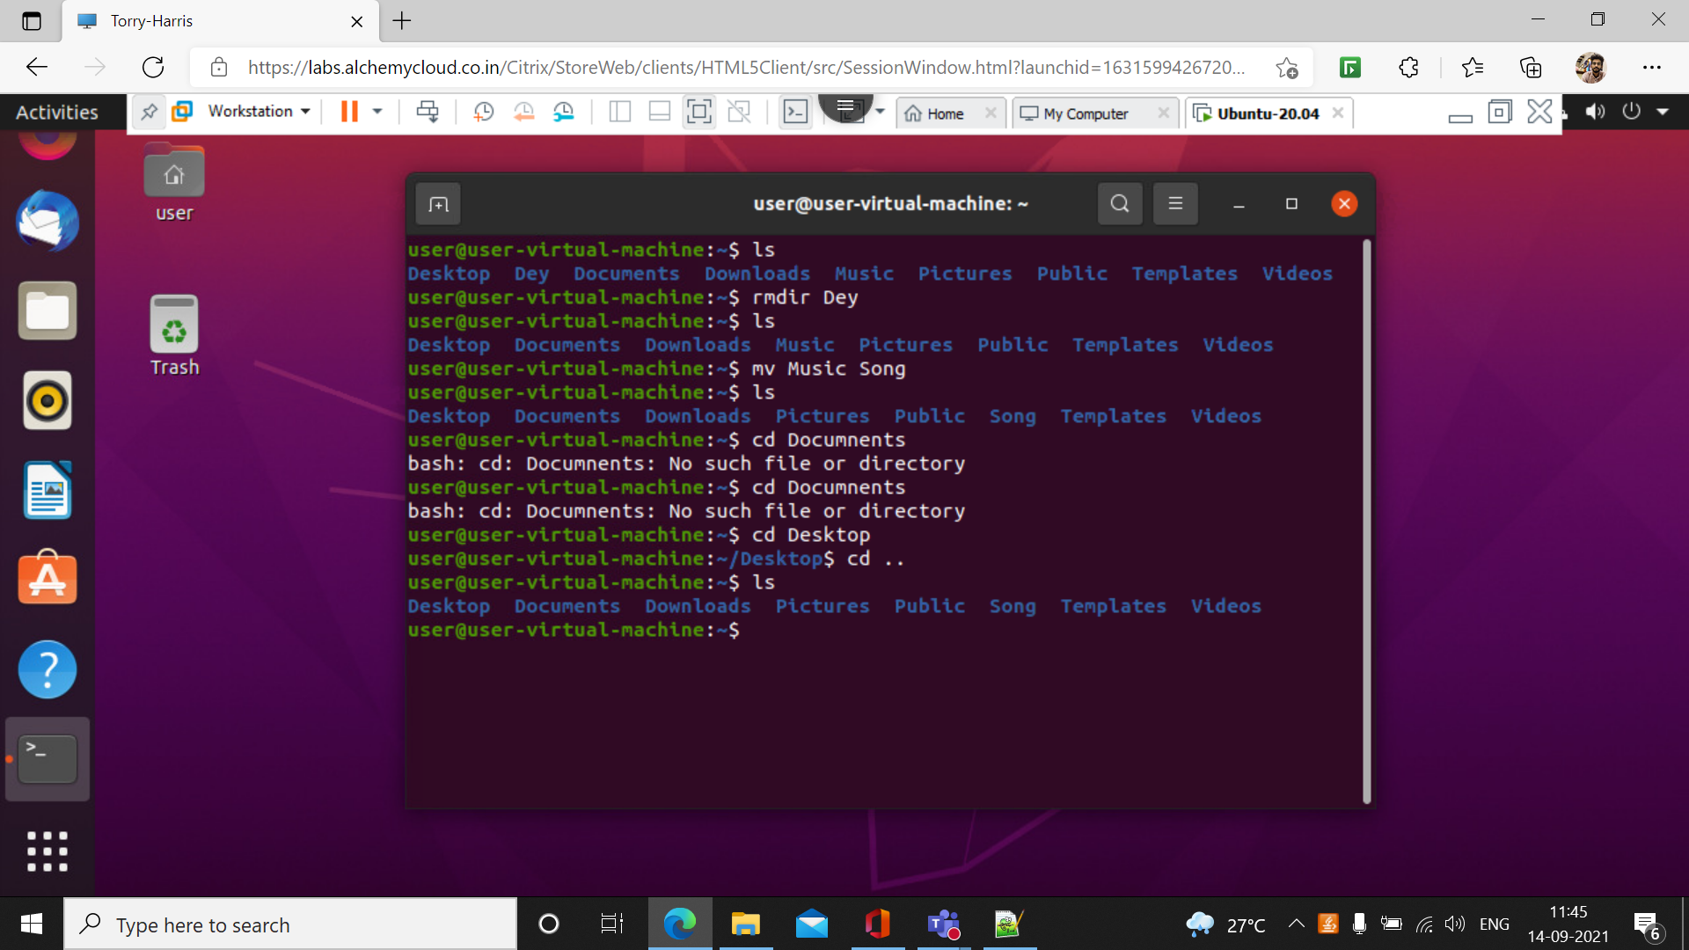

9.)echo

echo command is used to print the display the text or string

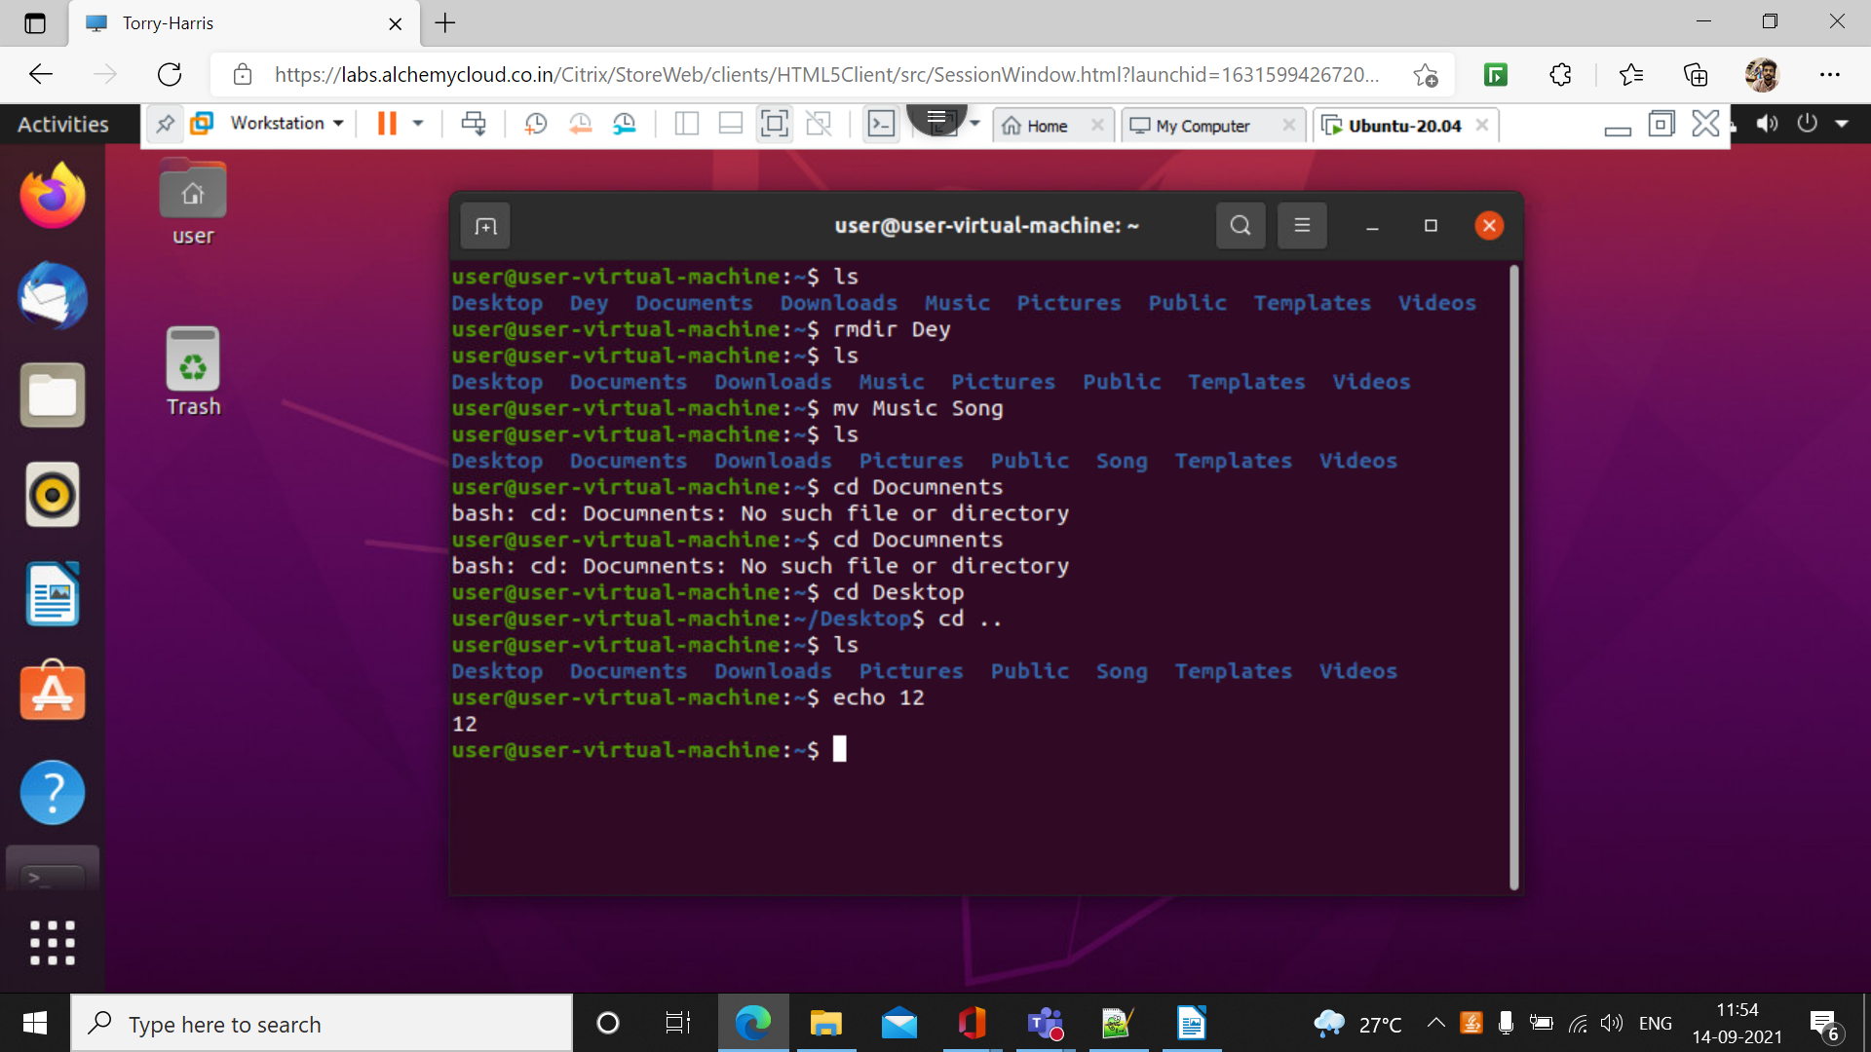

10.) man

Man command is used to display the user manual of any command .

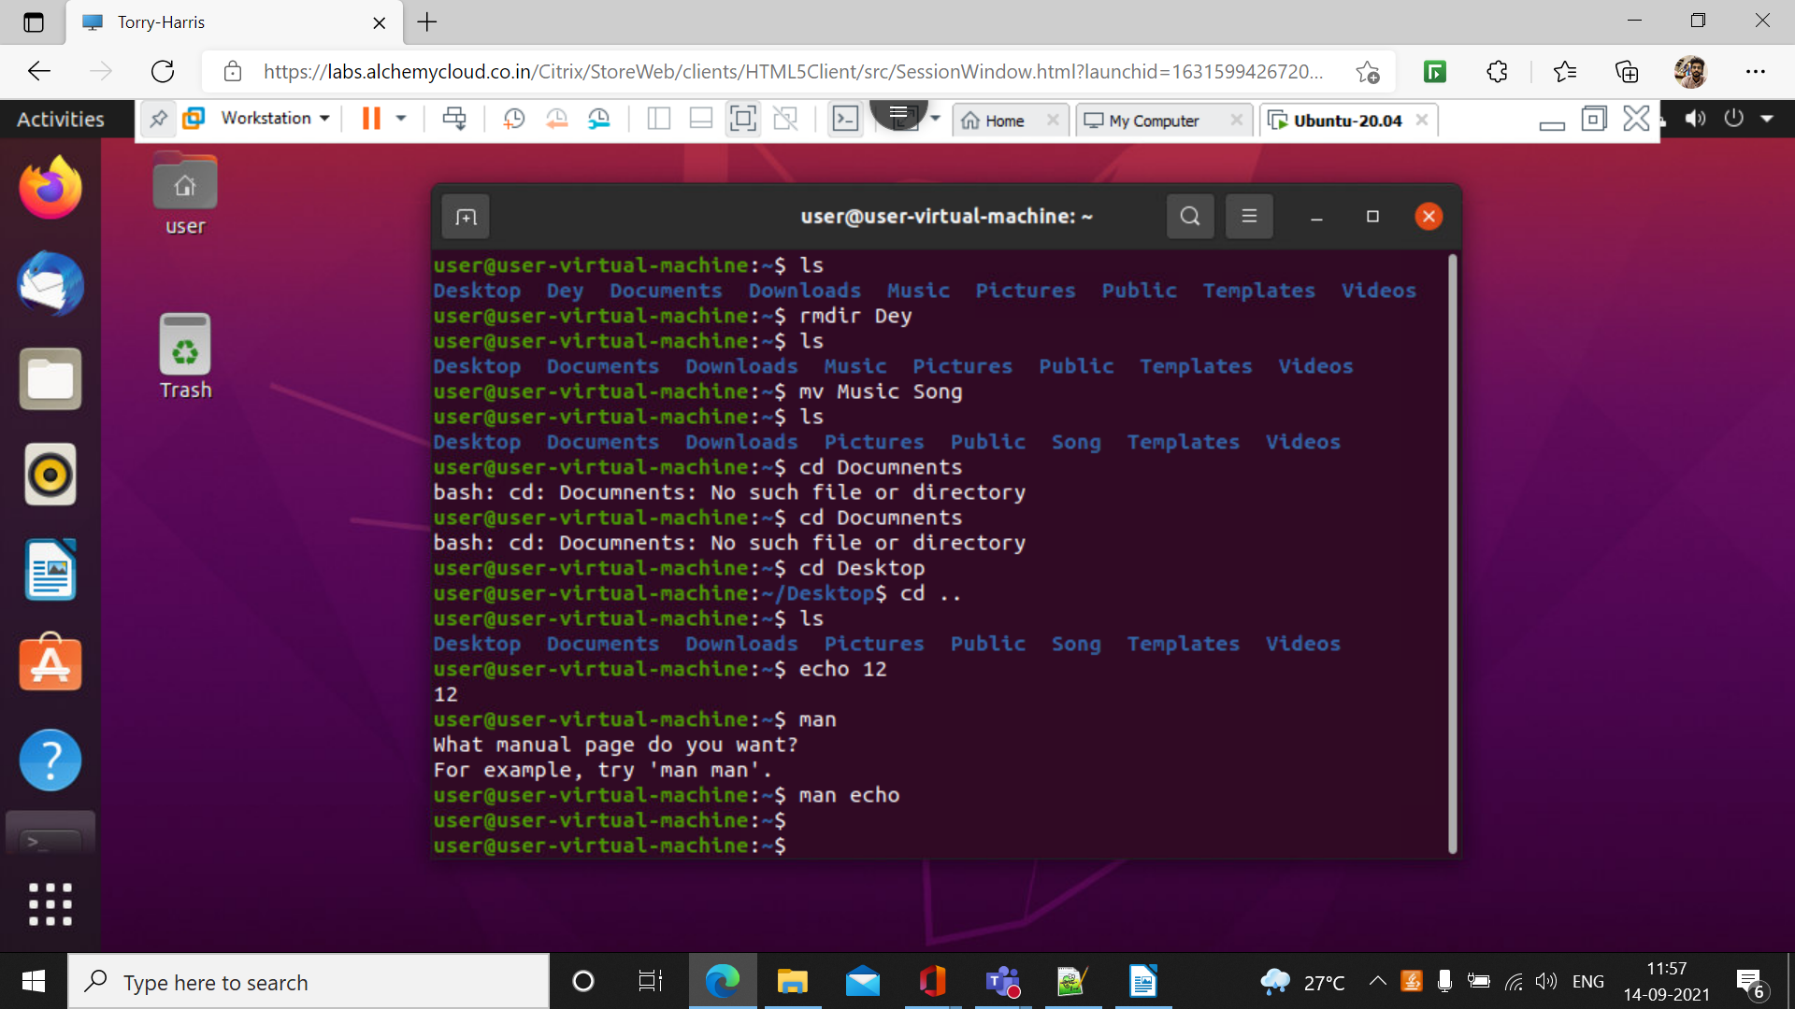

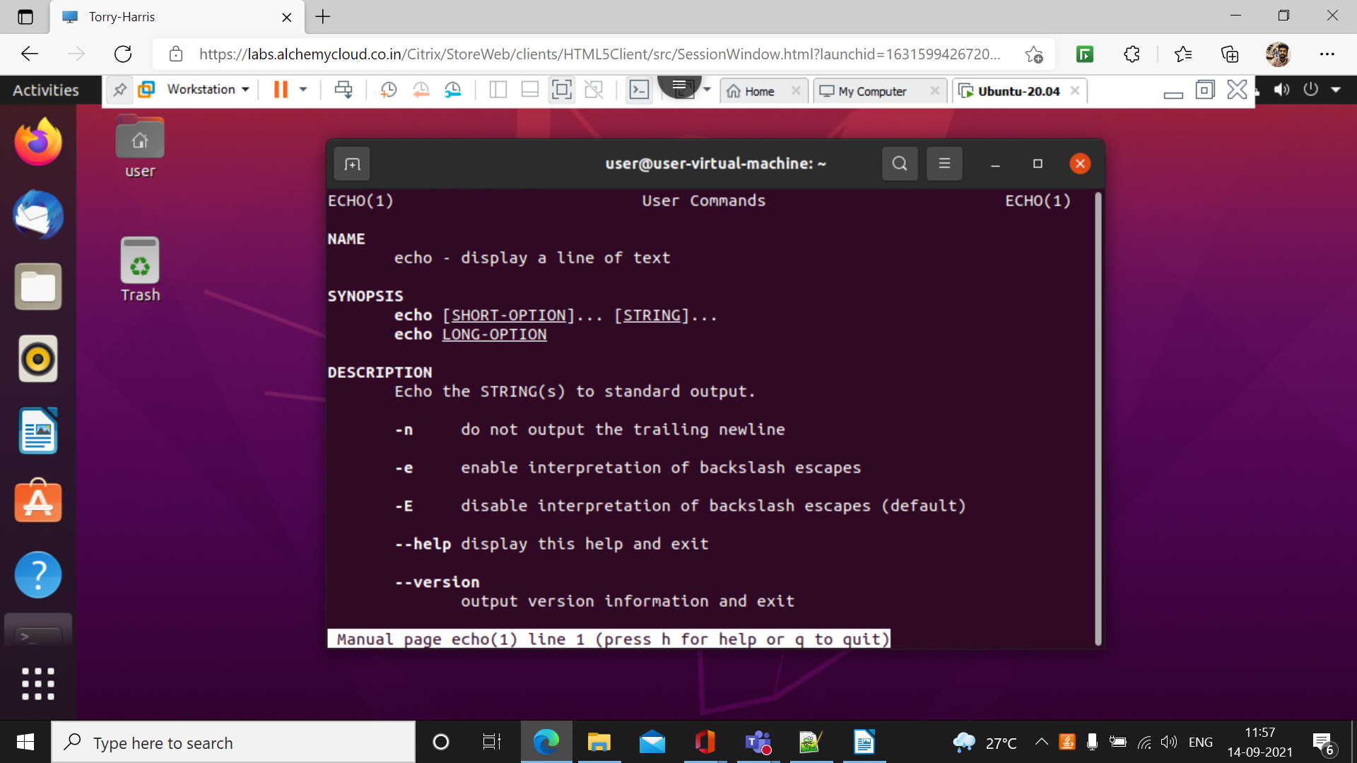

11.) mv

This command is used to rename the name of the current directory

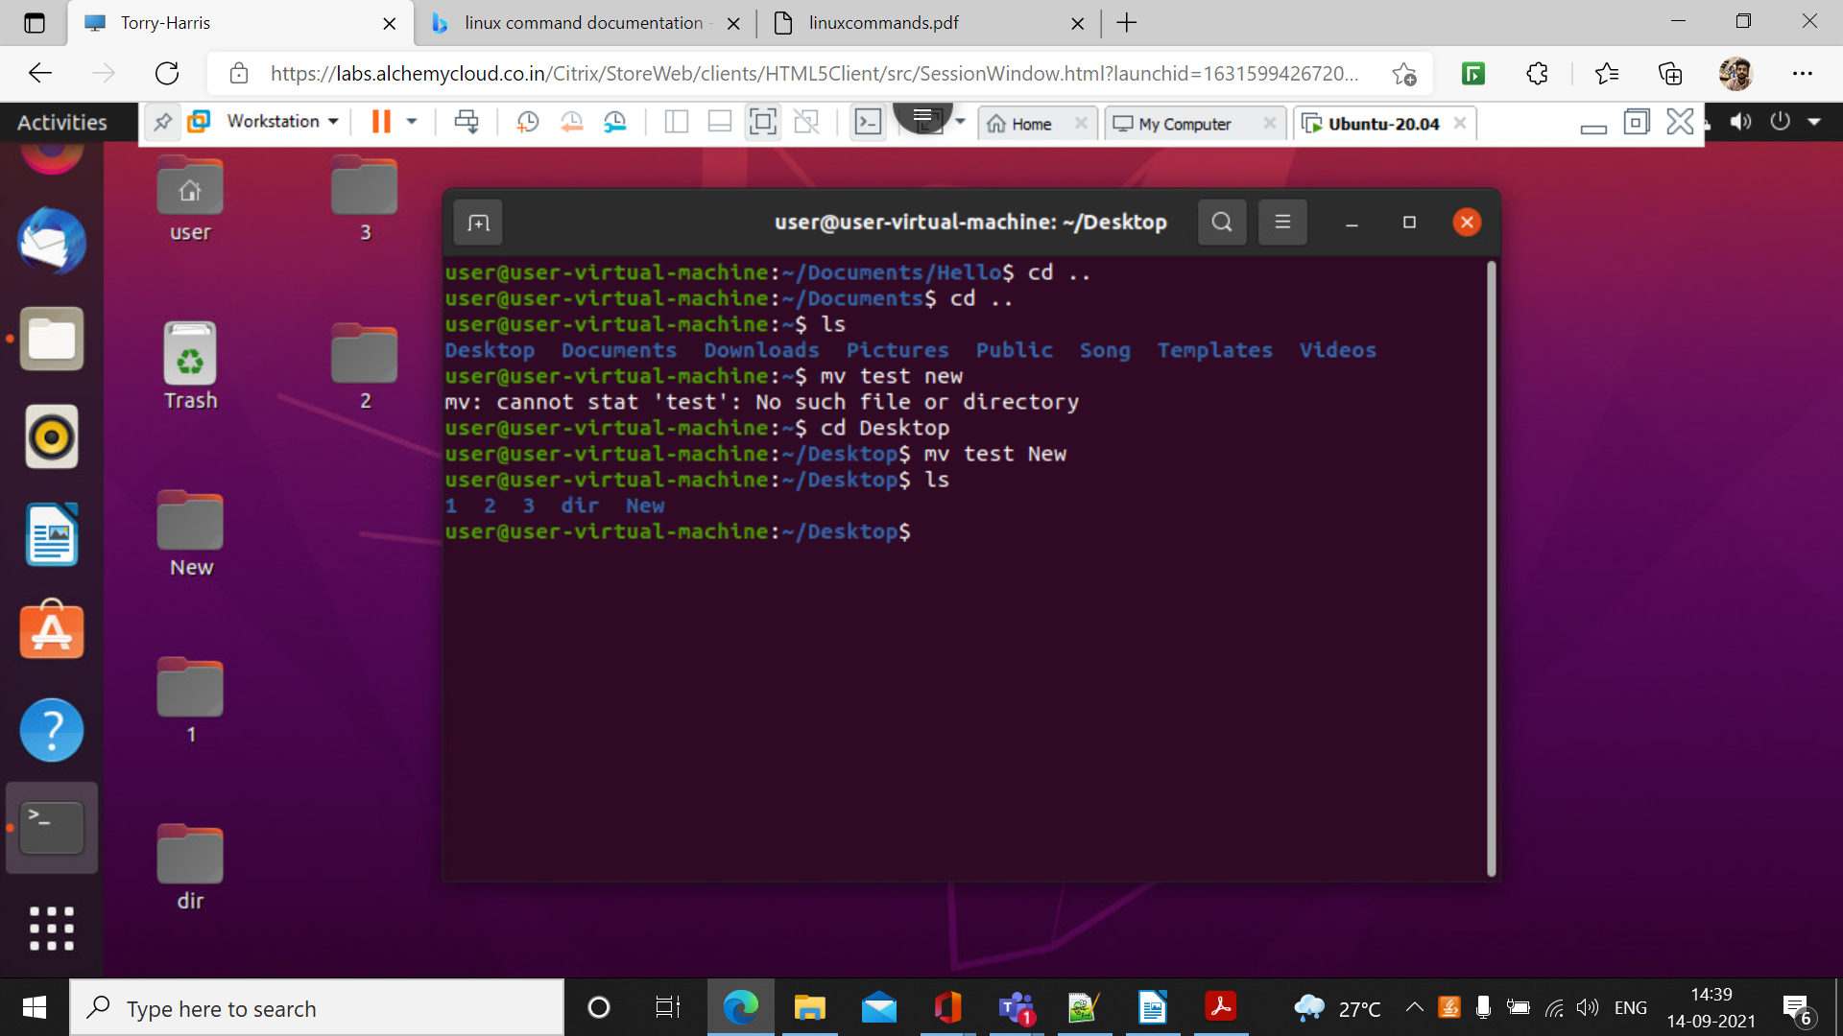

12.)ls -f

This command is used to list all the file present in the directories

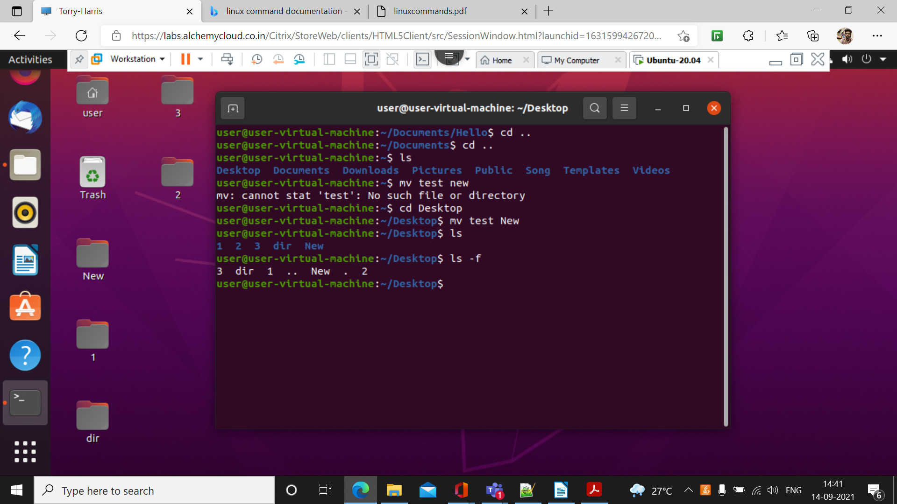

13.) ls -A

This command is used to view all the hidden folder in the directories

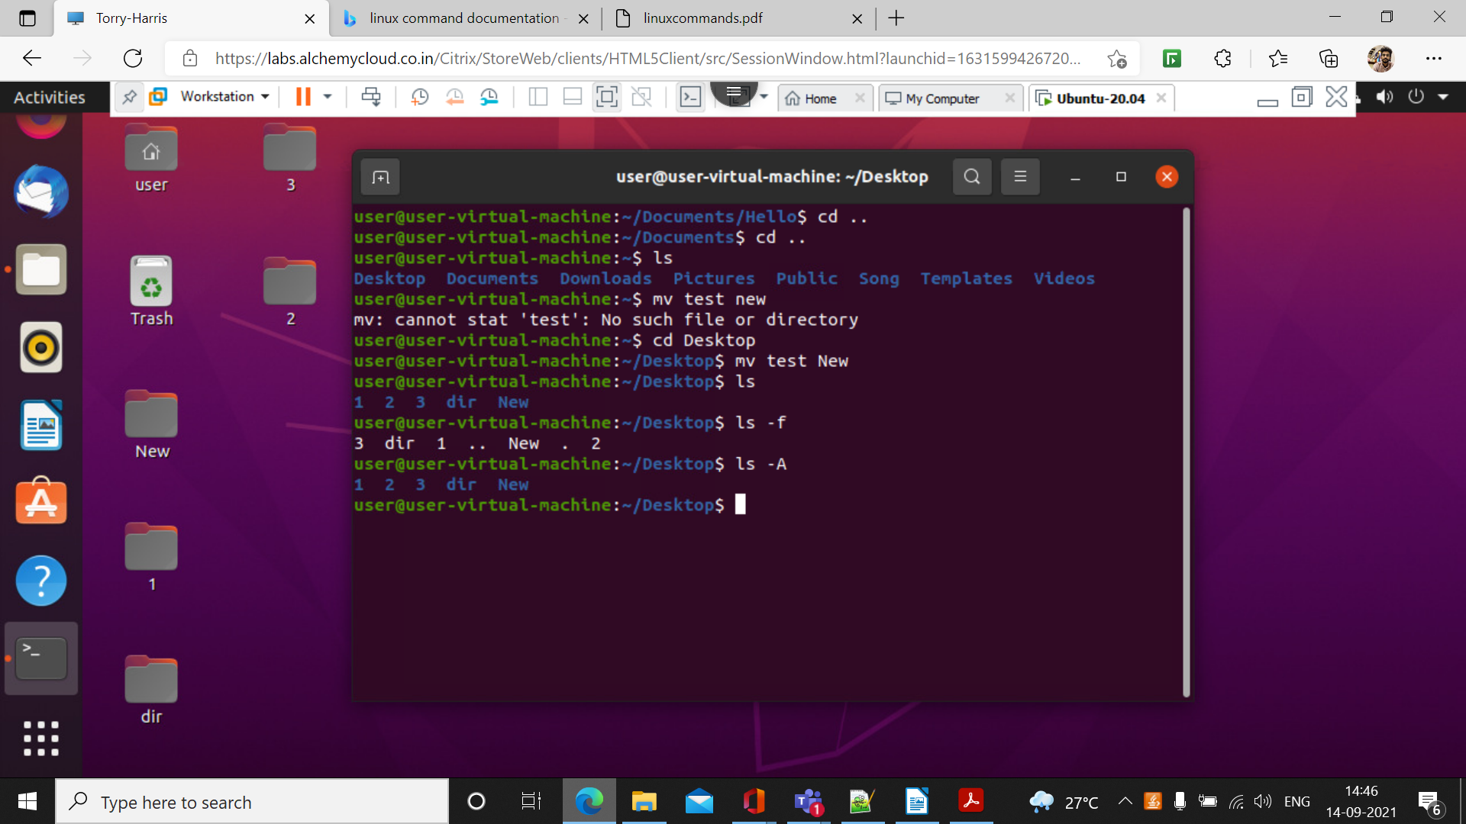

14.) ls -a

It show all the directories in alphabet order

